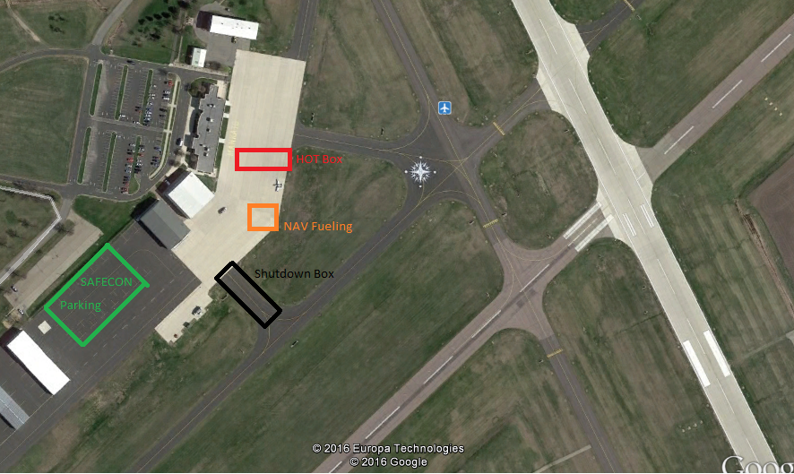
The airport is planning on having a fuel truck in the NAV fueling area to refuel aircraft returning from the NAV event. Should that not be available aircraft will make the left turn from the shutdown box and refuel at the self service pump.

