October 1, 2019

Request for Proposals: SAFECON 2021

SAFECON 2021 is quickly approaching and the National Intercollegiate Flying Association is now accepting proposals to host this exciting event. Basic guidelines are outlined below and for more information please contact the Executive Director, Taylor Newman, at taylor.newman@nifa.aero.

National SAFECON Guidelines:

- At least 10,000 sq. ft hangar space
- Parking and tie down area for at least 100 airplanes
- Towered airport
- Hotels in the community to support at least 500 occupants
- Offices or area for judges and administration
- Air-conditioned area for flight simulator device(s)
- Parking for at least 50 vehicles
- Banquet facility for 700

RFP should include:

- Budget for local involvement
- Plan for local involvement

RFP is closed November 20, 2019. Proposers will be afforded the opportunity to make presentations at NIFA’s Annual Business Meeting on Saturday May 23rd, 2020 at EAA’s Oshkosh facility.

Sincerely
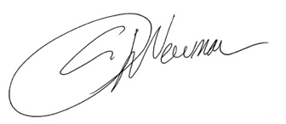
Taylor Newman
Executive Director

